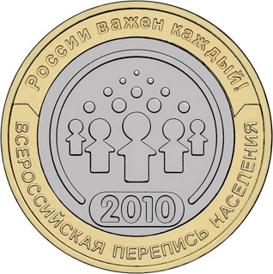
All-Russia population census (2010)
As part of the 2010 round of world population censuses, a census was conducted in the Russian Federation in October 2010. Information on the population as it stood at midnight on 14 October was collected from 14 October up to and including 25 October. The next population census in the Russian Federation is due to be conducted in 2020.
The main aim of the 2010 census was to find out the exact size of population across all population centres in the country, ranging from “millionaires’ cities” to the very smallest villages that may have just one inhabitant.
The particular features of population censuses in the Russian Federation are:
(a) The large size of the country – 171 million square kilometres spread over 9
time zones;
(b) The significant proportion (almost 75 per cent) of territory lying within the
Far North and similar territories. The census of over 1,600 population centres in these areas was conducted between 1 April and 20 December 2010 as transport connections permitted. Information on about half a million people was gathered;
(c) The uneven distribution of the population across the country. Population
density, measured in persons per square kilometre, reaches 9,500 in Moscow and 3,300 in St. Petersburg, whereas in Chukotka and the Nenets Autonomous Area it is 0.1 and 0.2 respectively and the average population density for the entire country is 8.3;
(d) The significant number of population centres, including small ones, and their
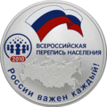
remoteness from each other. The country counts 2,386 small cities and big towns, 12 cities with populations of over 1 million and 153,000 villages.
The 2010 census was conducted on the basis of the Federal All-Russian Population Census Act, which makes participation a civil and social obligation. The list of questions under the Act, on which population data are collected does not include a person’s family name, first name or patronymic. The information on the census forms is anonymized.
Thus, to obtain complete information on the size of the population, check the completion of census forms by census personnel and ensure that there was no undercounting or overcounting, lists of people to be counted in the census were created indicating family name, first name, patronymic and temporary or permanent address.
During the 2010 census, information about the population was collected by various methods, in keeping with the Federal Act. Census personnel collected information from 94 per cent of the population by visiting all premises where people might be living. Respondents not wishing to allow census personnel into their homes and homeless persons could complete the census at census stations (6 per cent did). In individual cases people were permitted to respond to the census by telephone.
Monitoring procedures were set up to ensure that data on the population size was reliable: people with more than one home were identified, notifications of the census were issued and premises were visited and checked.
At the end of the census, administrative sources from their places of permanent residence were used to ascertain the sex and date of birth of everyone who had refused to take part (1 million) and people whom the census personnel were unable to find over the census period (2.6 million) and only these two fields on the census form were completed for these 3.6 million individuals.
All this resulted in an exact figure for the total population of 142.9 million (the difference between this and the most recent estimate of population size was 1,007,600, that is, 0.7 per cent). The difference is accounted for by amendments made to migration legislation in 2006.
In addition, because it was not compulsory to provide personal information, considerably more people than in the previous census, did not respond to certain questions on the census form for one reason or another.

